Styrkarr, Der Doctor Schnabel

Obverse: Duke Styrkarr of An Tir is, in real life, an MD. This image was engraved from pictures of a mask Ugo Serrano made. The mask is based on the outfits worn by Der Doctor Schnabel von Rom, the real Plague Doctors of 1656. Known as the beaked (schnabel) doctors.

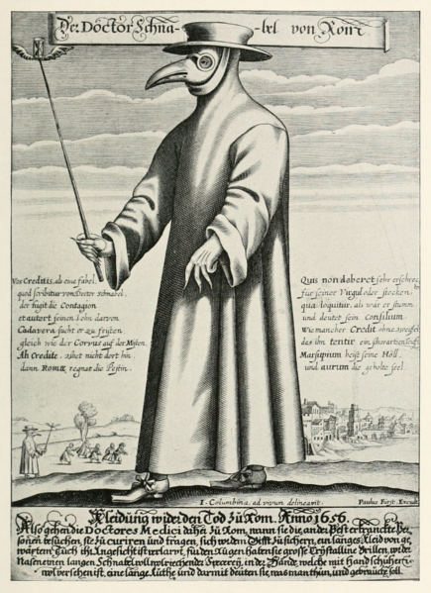 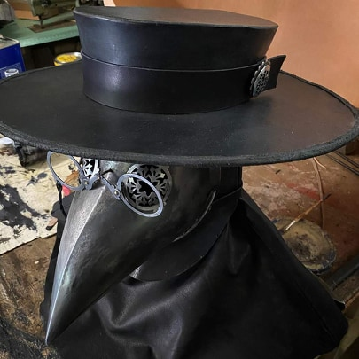

Reverse: A diagram of the SARS-CoV 2 virus that causes COVID-19.

Legend: CORONA.PESTILENCE\*\*2020\*\* ( the stars represent those that died).



25 mm x 8 mm coins are hammer struck in 3% silver/97% tin custom alloy pewter and fine silver.

